# Maximal model results

Similarity contrast results when fitting maximal models with all random effects.

## Phase coupling

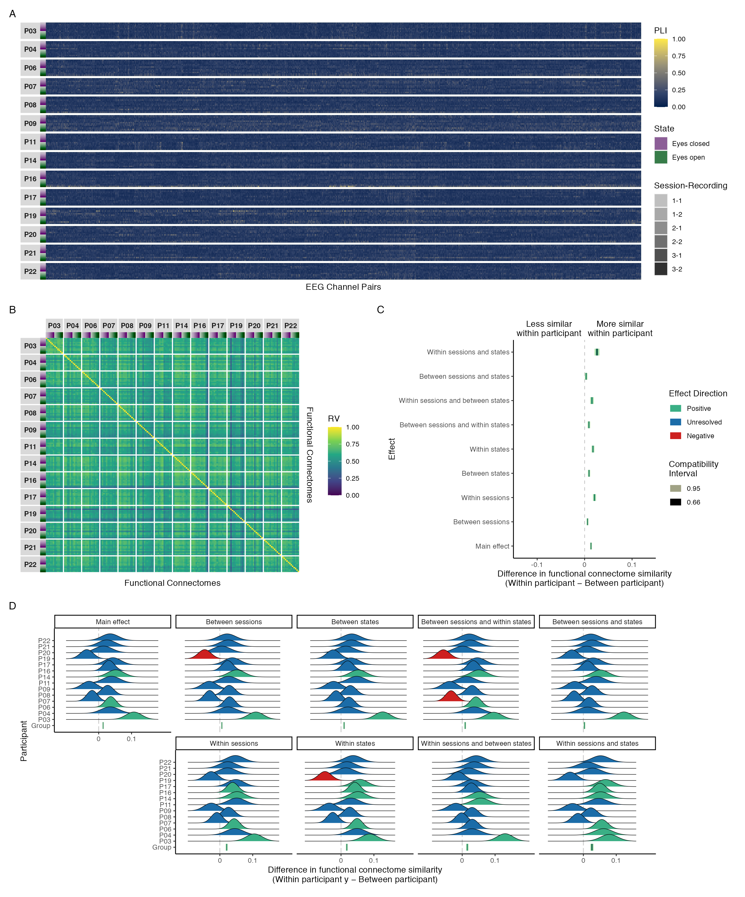

Figure 1: Connectivity profiles for all recordings by participant (A), functional connectome similarities within and between participants (B), group-level contrasts estimating the difference in functional connectome similarity within and between participants at various levels of the session and state predictors (C), and individual-level contrasts estimating the difference in functional connectome similarity within and between participants at various levels of the session and state predictors (D) for phase coupling functional connectome similarities in the delta band.

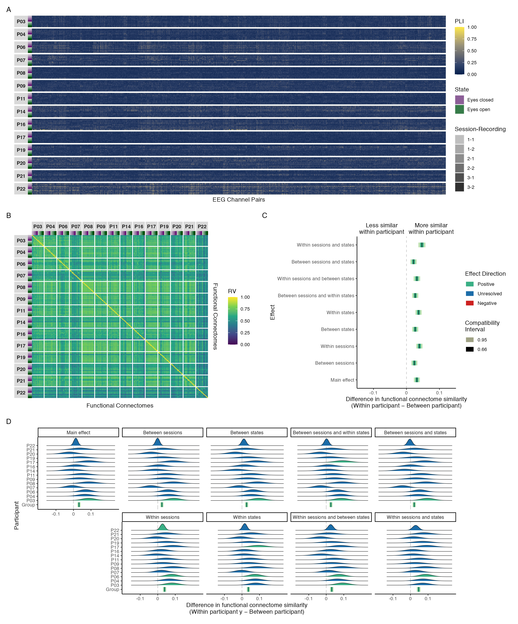

Figure 2: Connectivity profile matrix (A), similarity matrix (B), interval plot (C), and ridge plots (D) for phase coupling functional connectome similarities in the theta band.

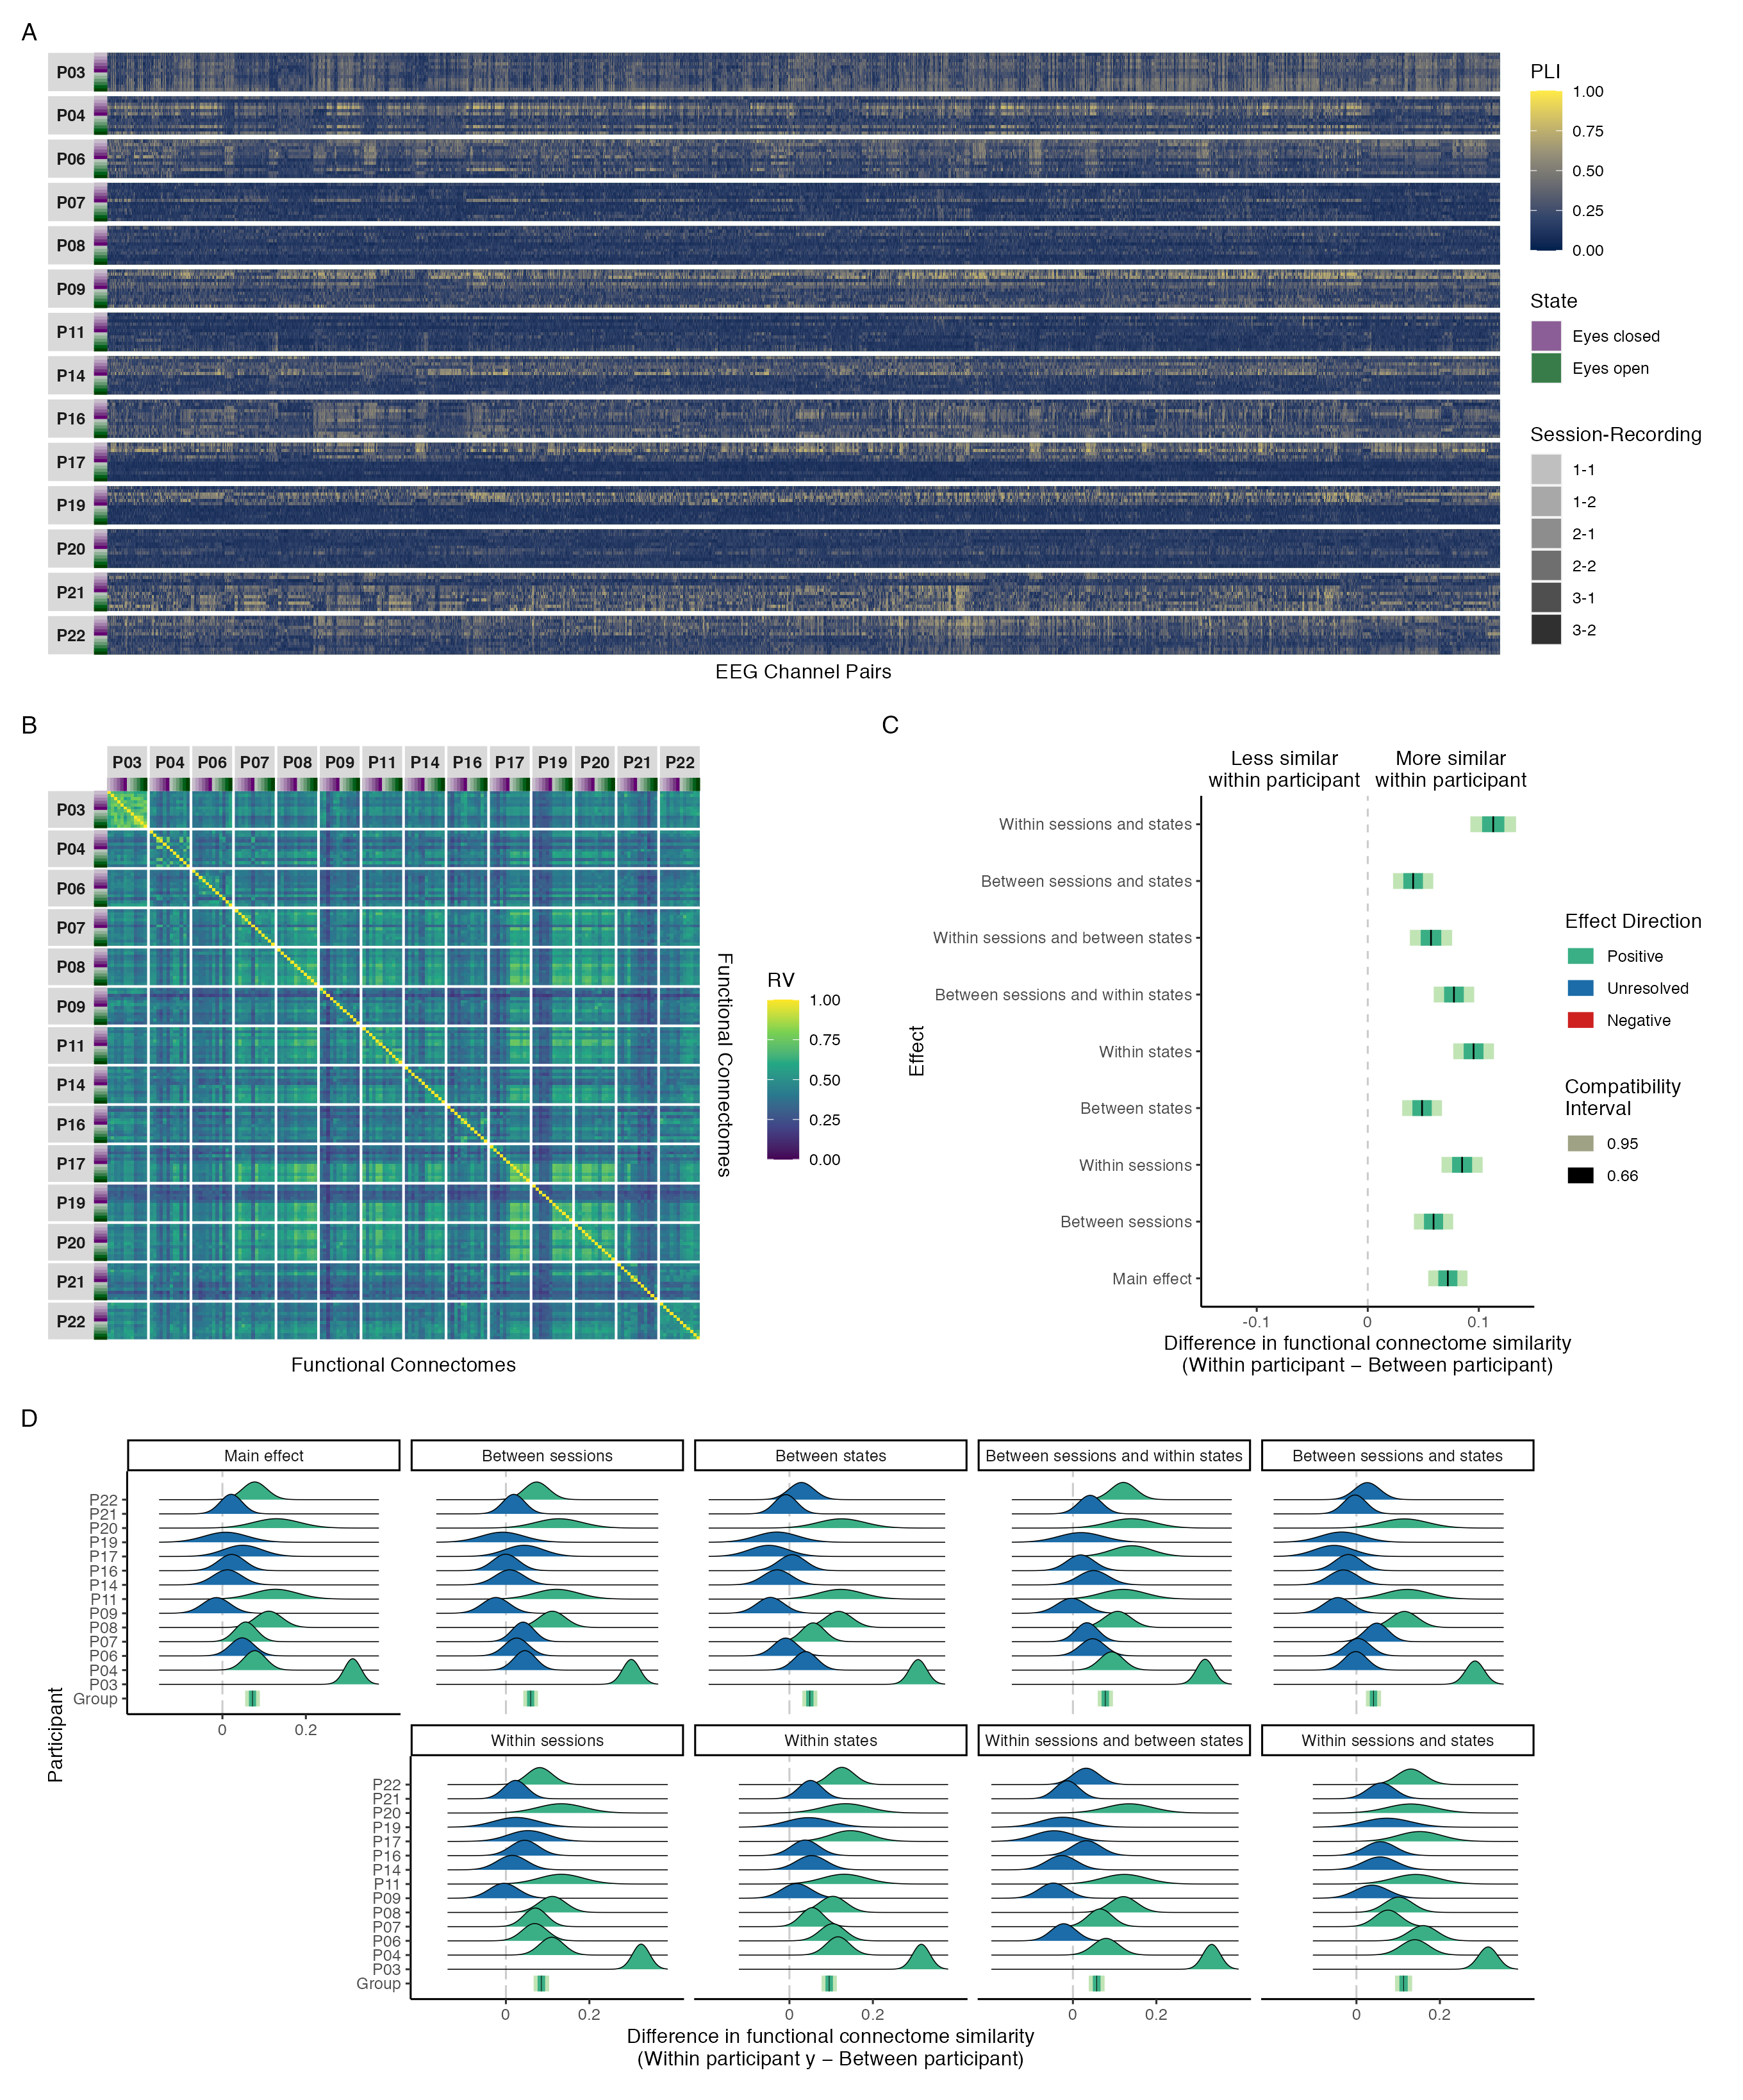

Figure 3: Connectivity profile matrix (A), similarity matrix (B), interval plot (C), and ridge plots (D) for phase coupling functional connectome similarities in the alpha band.

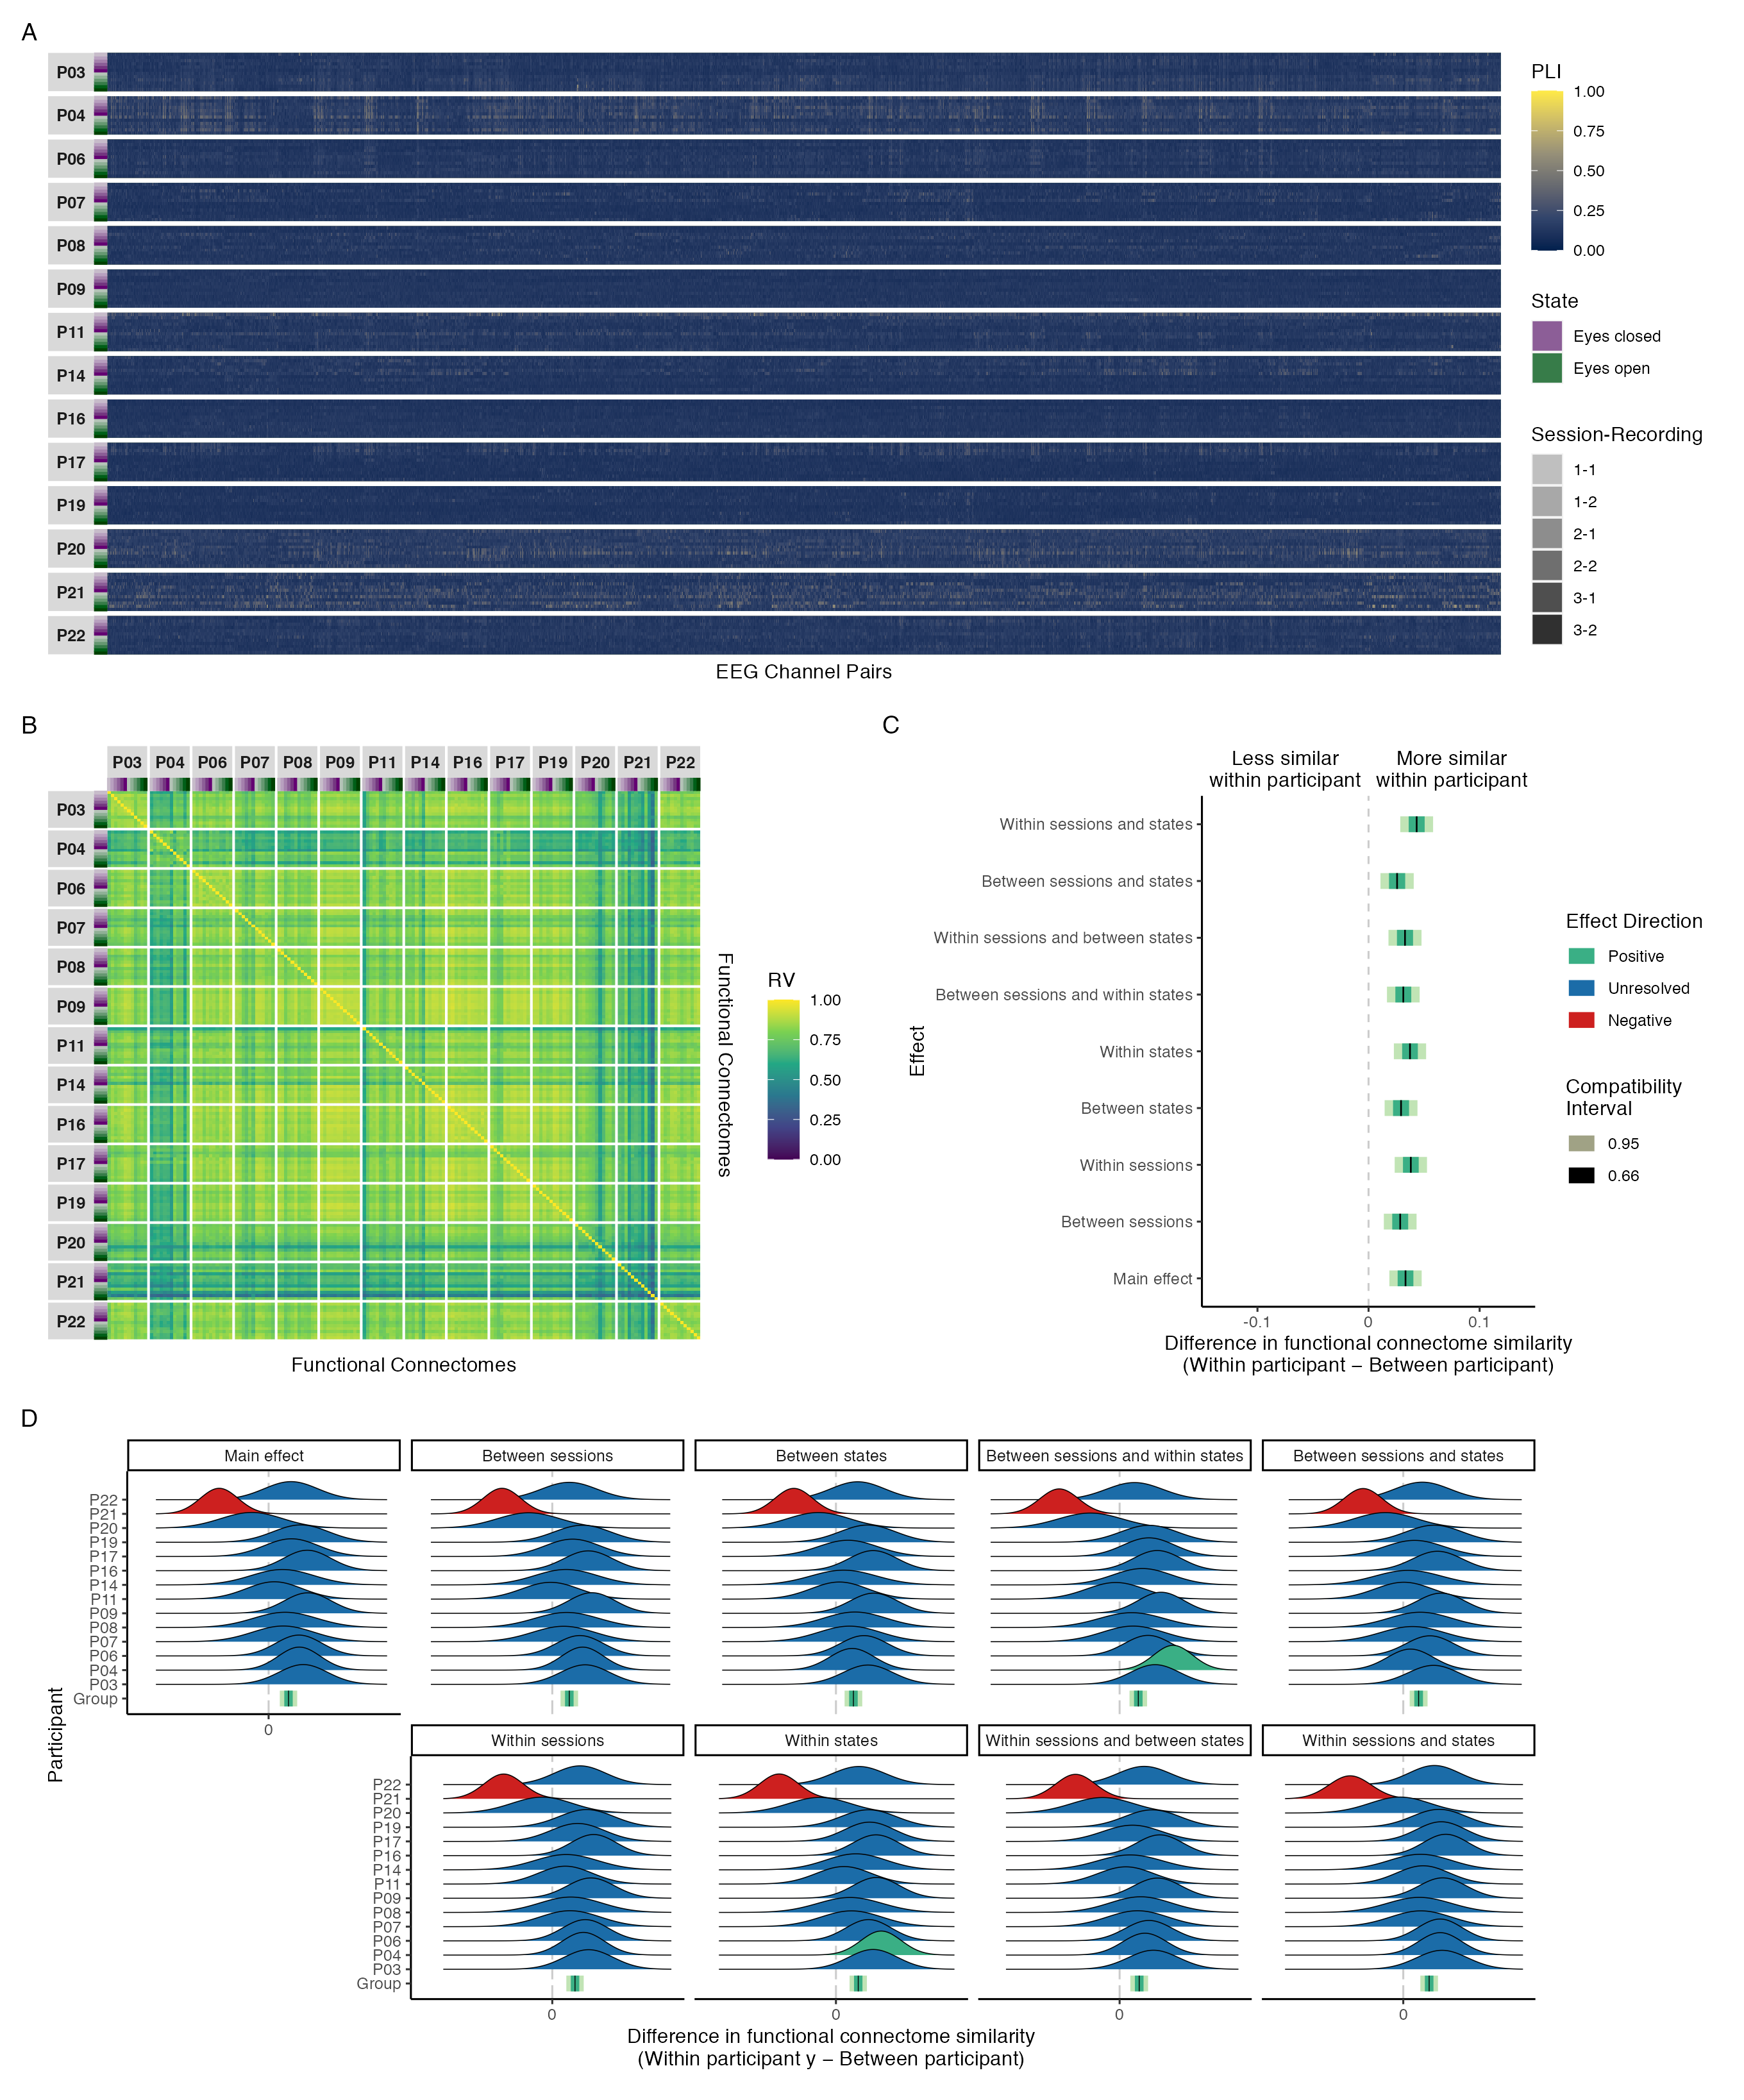

Figure 4: Connectivity profile matrix (A), similarity matrix (B), interval plot (C), and ridge plots (D) for phase coupling functional connectome similarities in the beta band.

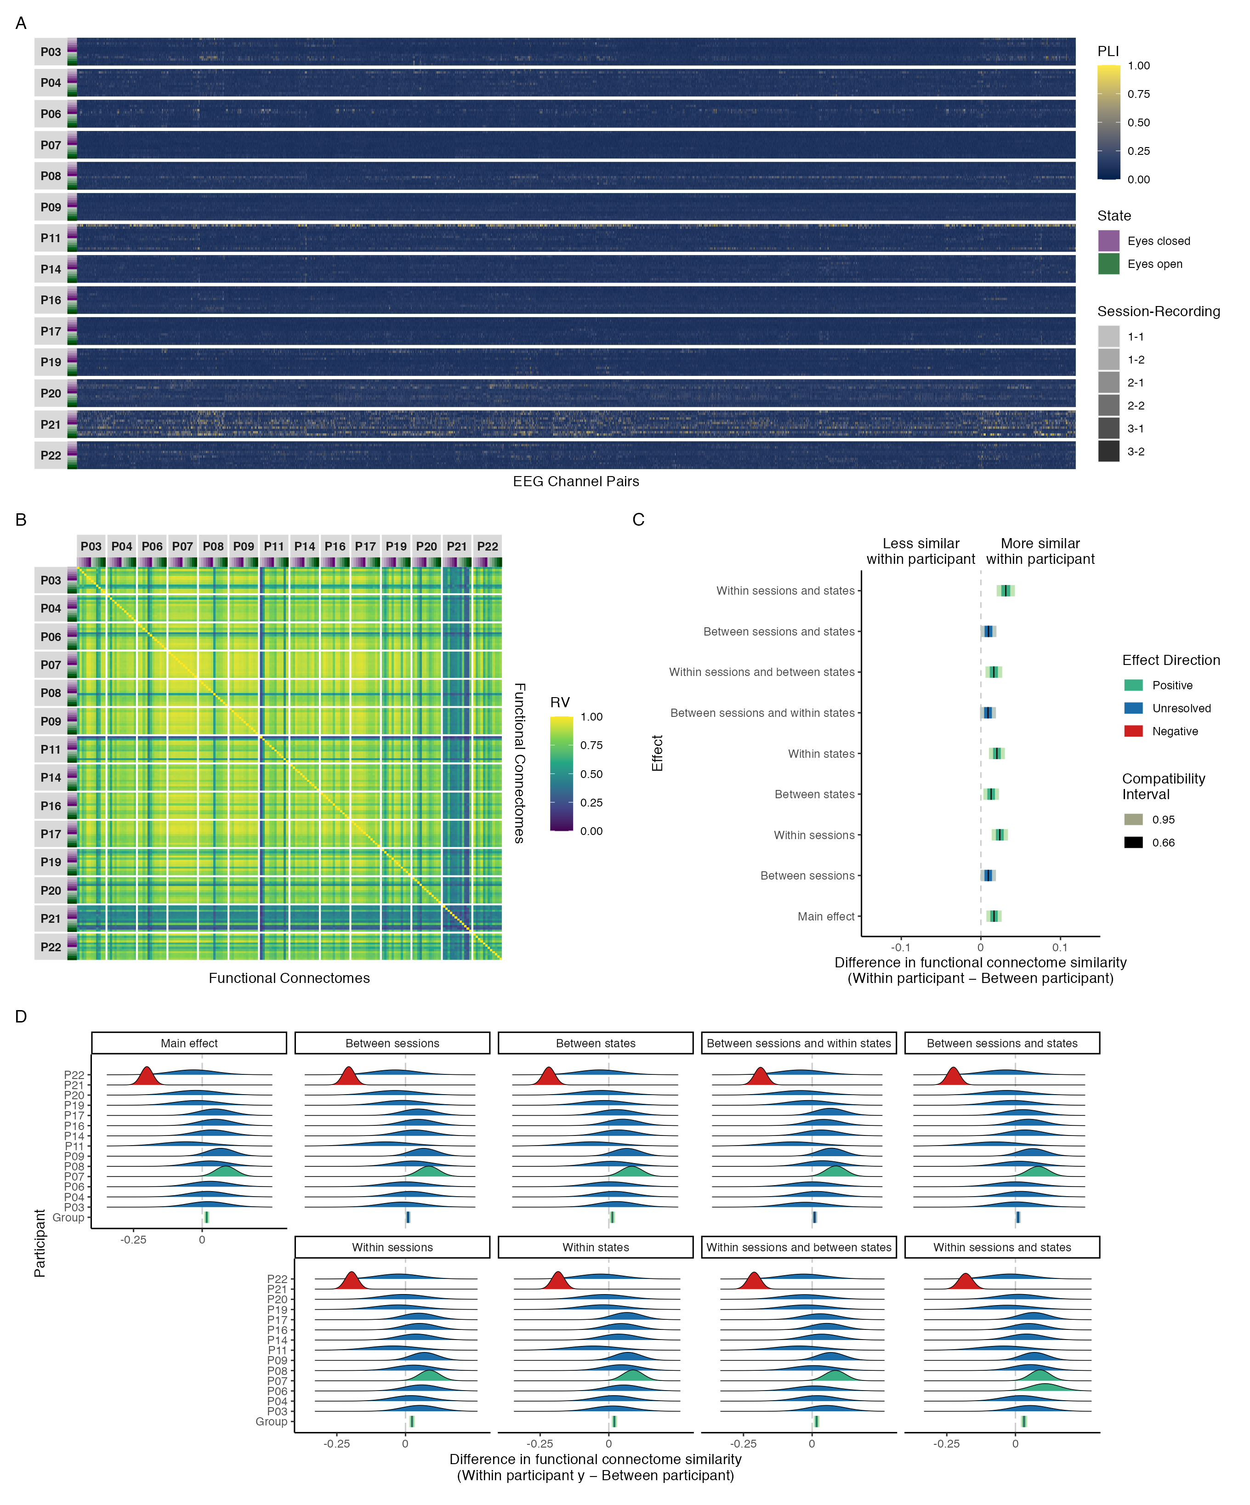

Figure 5: Connectivity profile matrix (A), similarity matrix (B), interval plot (C), and ridge plots (D) for phase coupling functional connectome similarities in the gamma band.

## Amplitude coupling

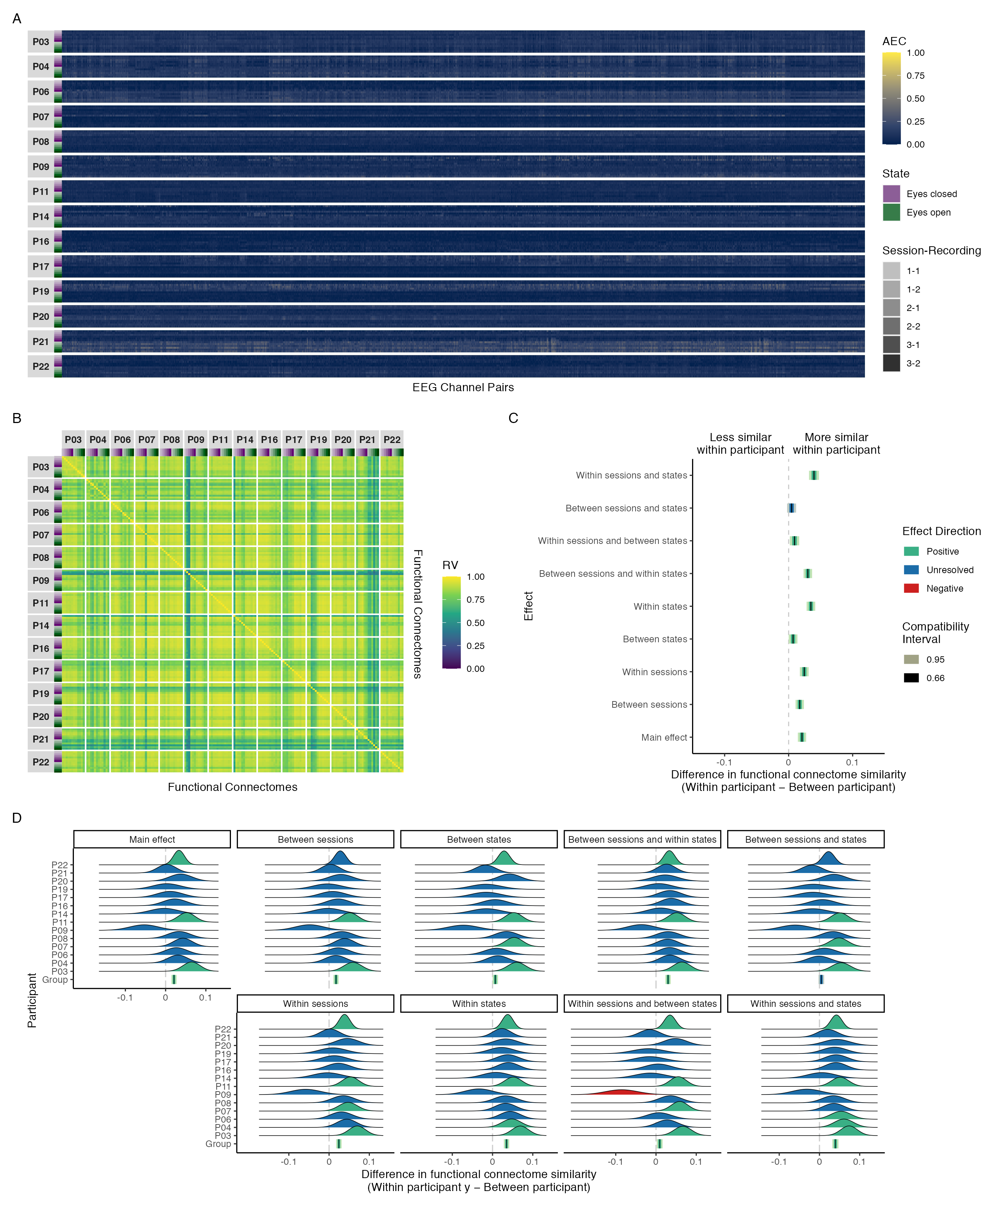

Figure 6: Connectivity profile matrix (A), similarity matrix (B), interval plot (C), and ridge plots (D) for amplitude coupling functional connectome similarities in the alpha band.

### Delta, Theta, Beta, and Gamma bands

Not shown for the same reasons as explained in the manuscript.

## Phase coupling (Hilbert transform)

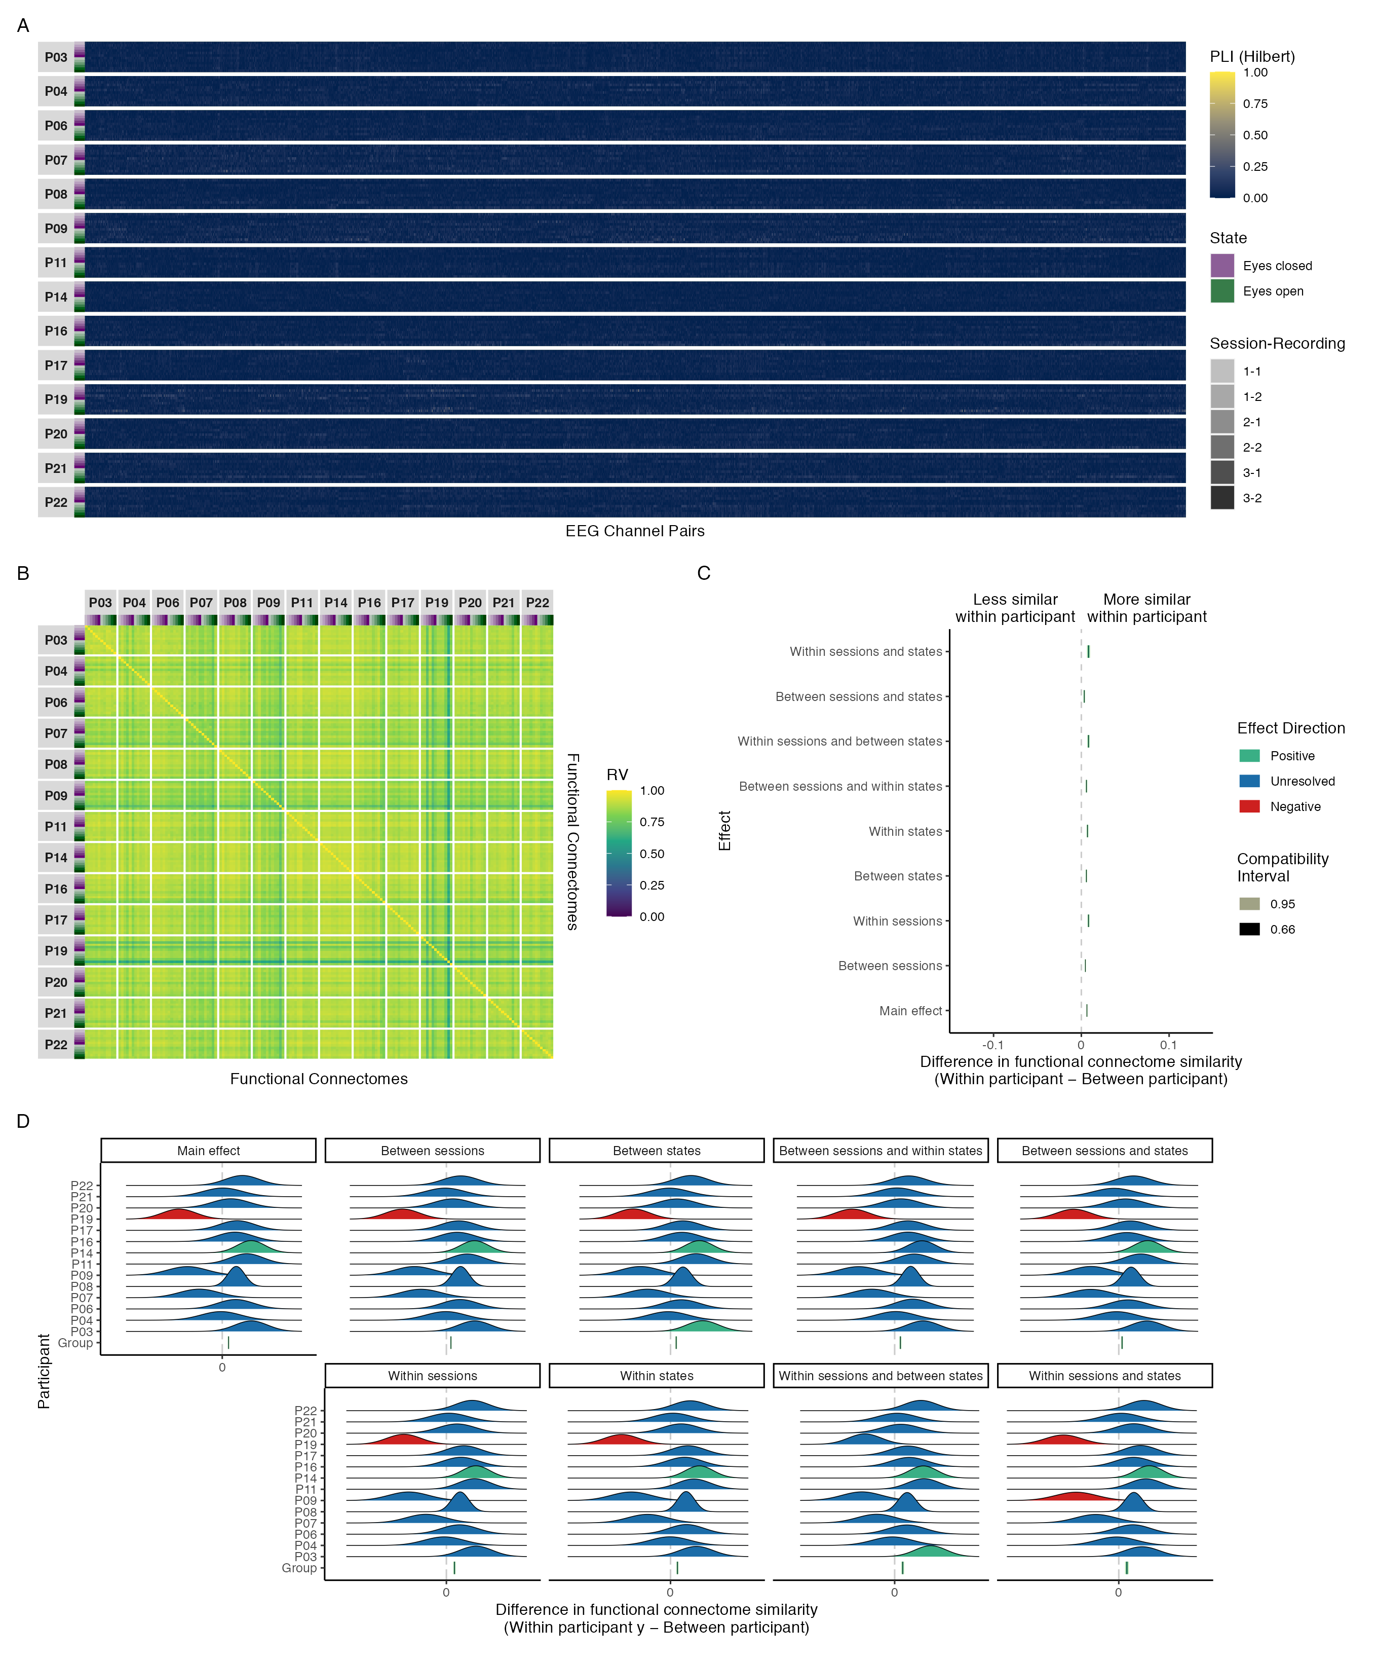

Figure 7: Connectivity profiles for all recordings by participant (A), functional connectome similarities within and between participants (B), group-level contrasts estimating the difference in functional connectome similarity within and between participants at various levels of the session and state predictors (C), and individual-level contrasts estimating the difference in functional connectome similarity within and between participants at various levels of the session and state predictors (D) for phase coupling functional connectome similarities in the delta band.

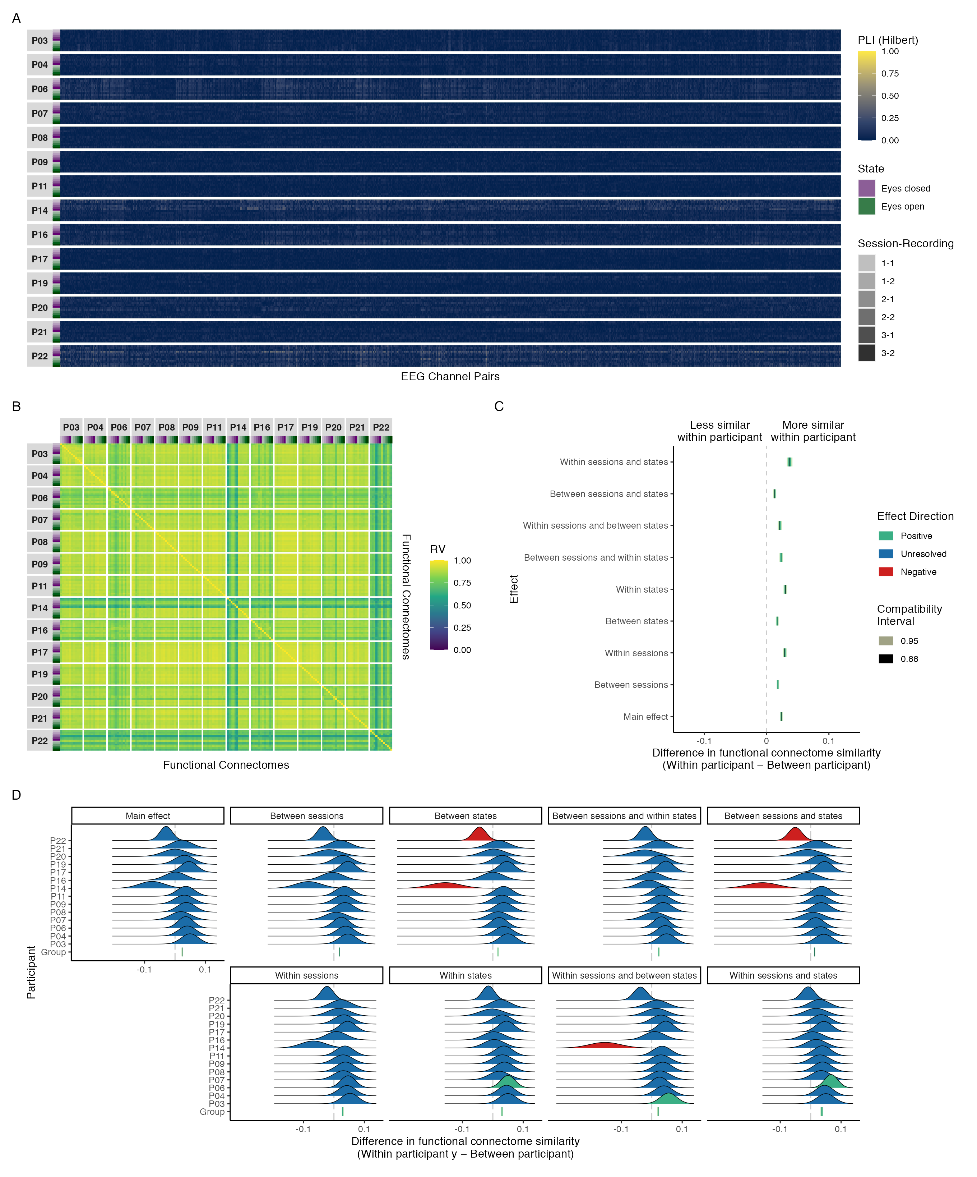

Figure 8: Connectivity profile matrix (A), similarity matrix (B), interval plot (C), and ridge plots (D) for phase coupling functional connectome similarities in the theta band.

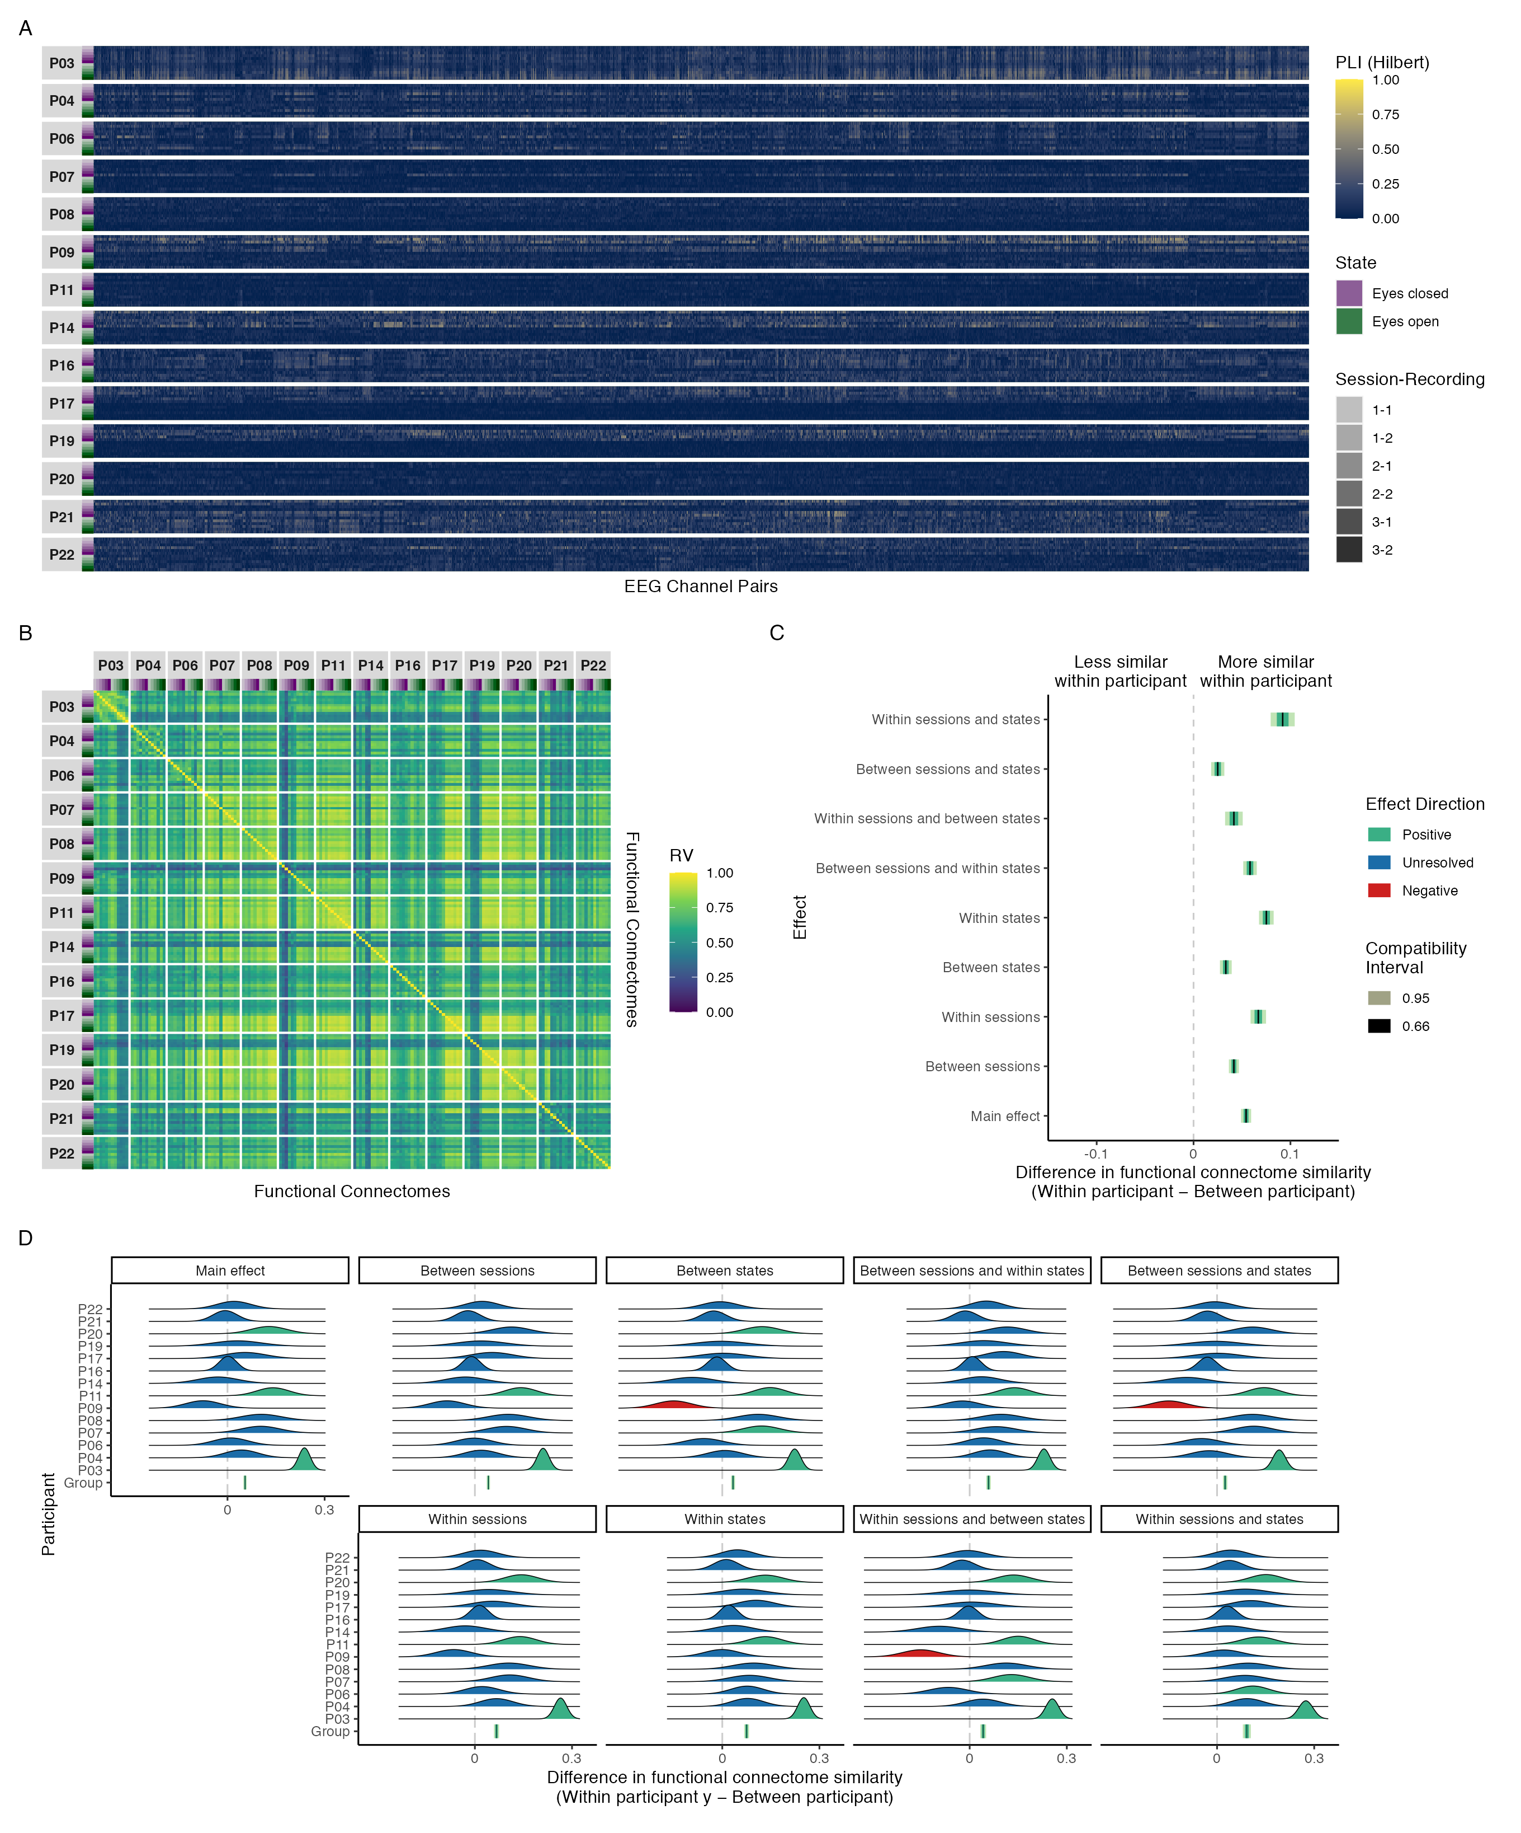

Figure 9: Connectivity profile matrix (A), similarity matrix (B), interval plot (C), and ridge plots (D) for phase coupling functional connectome similarities in the alpha band.

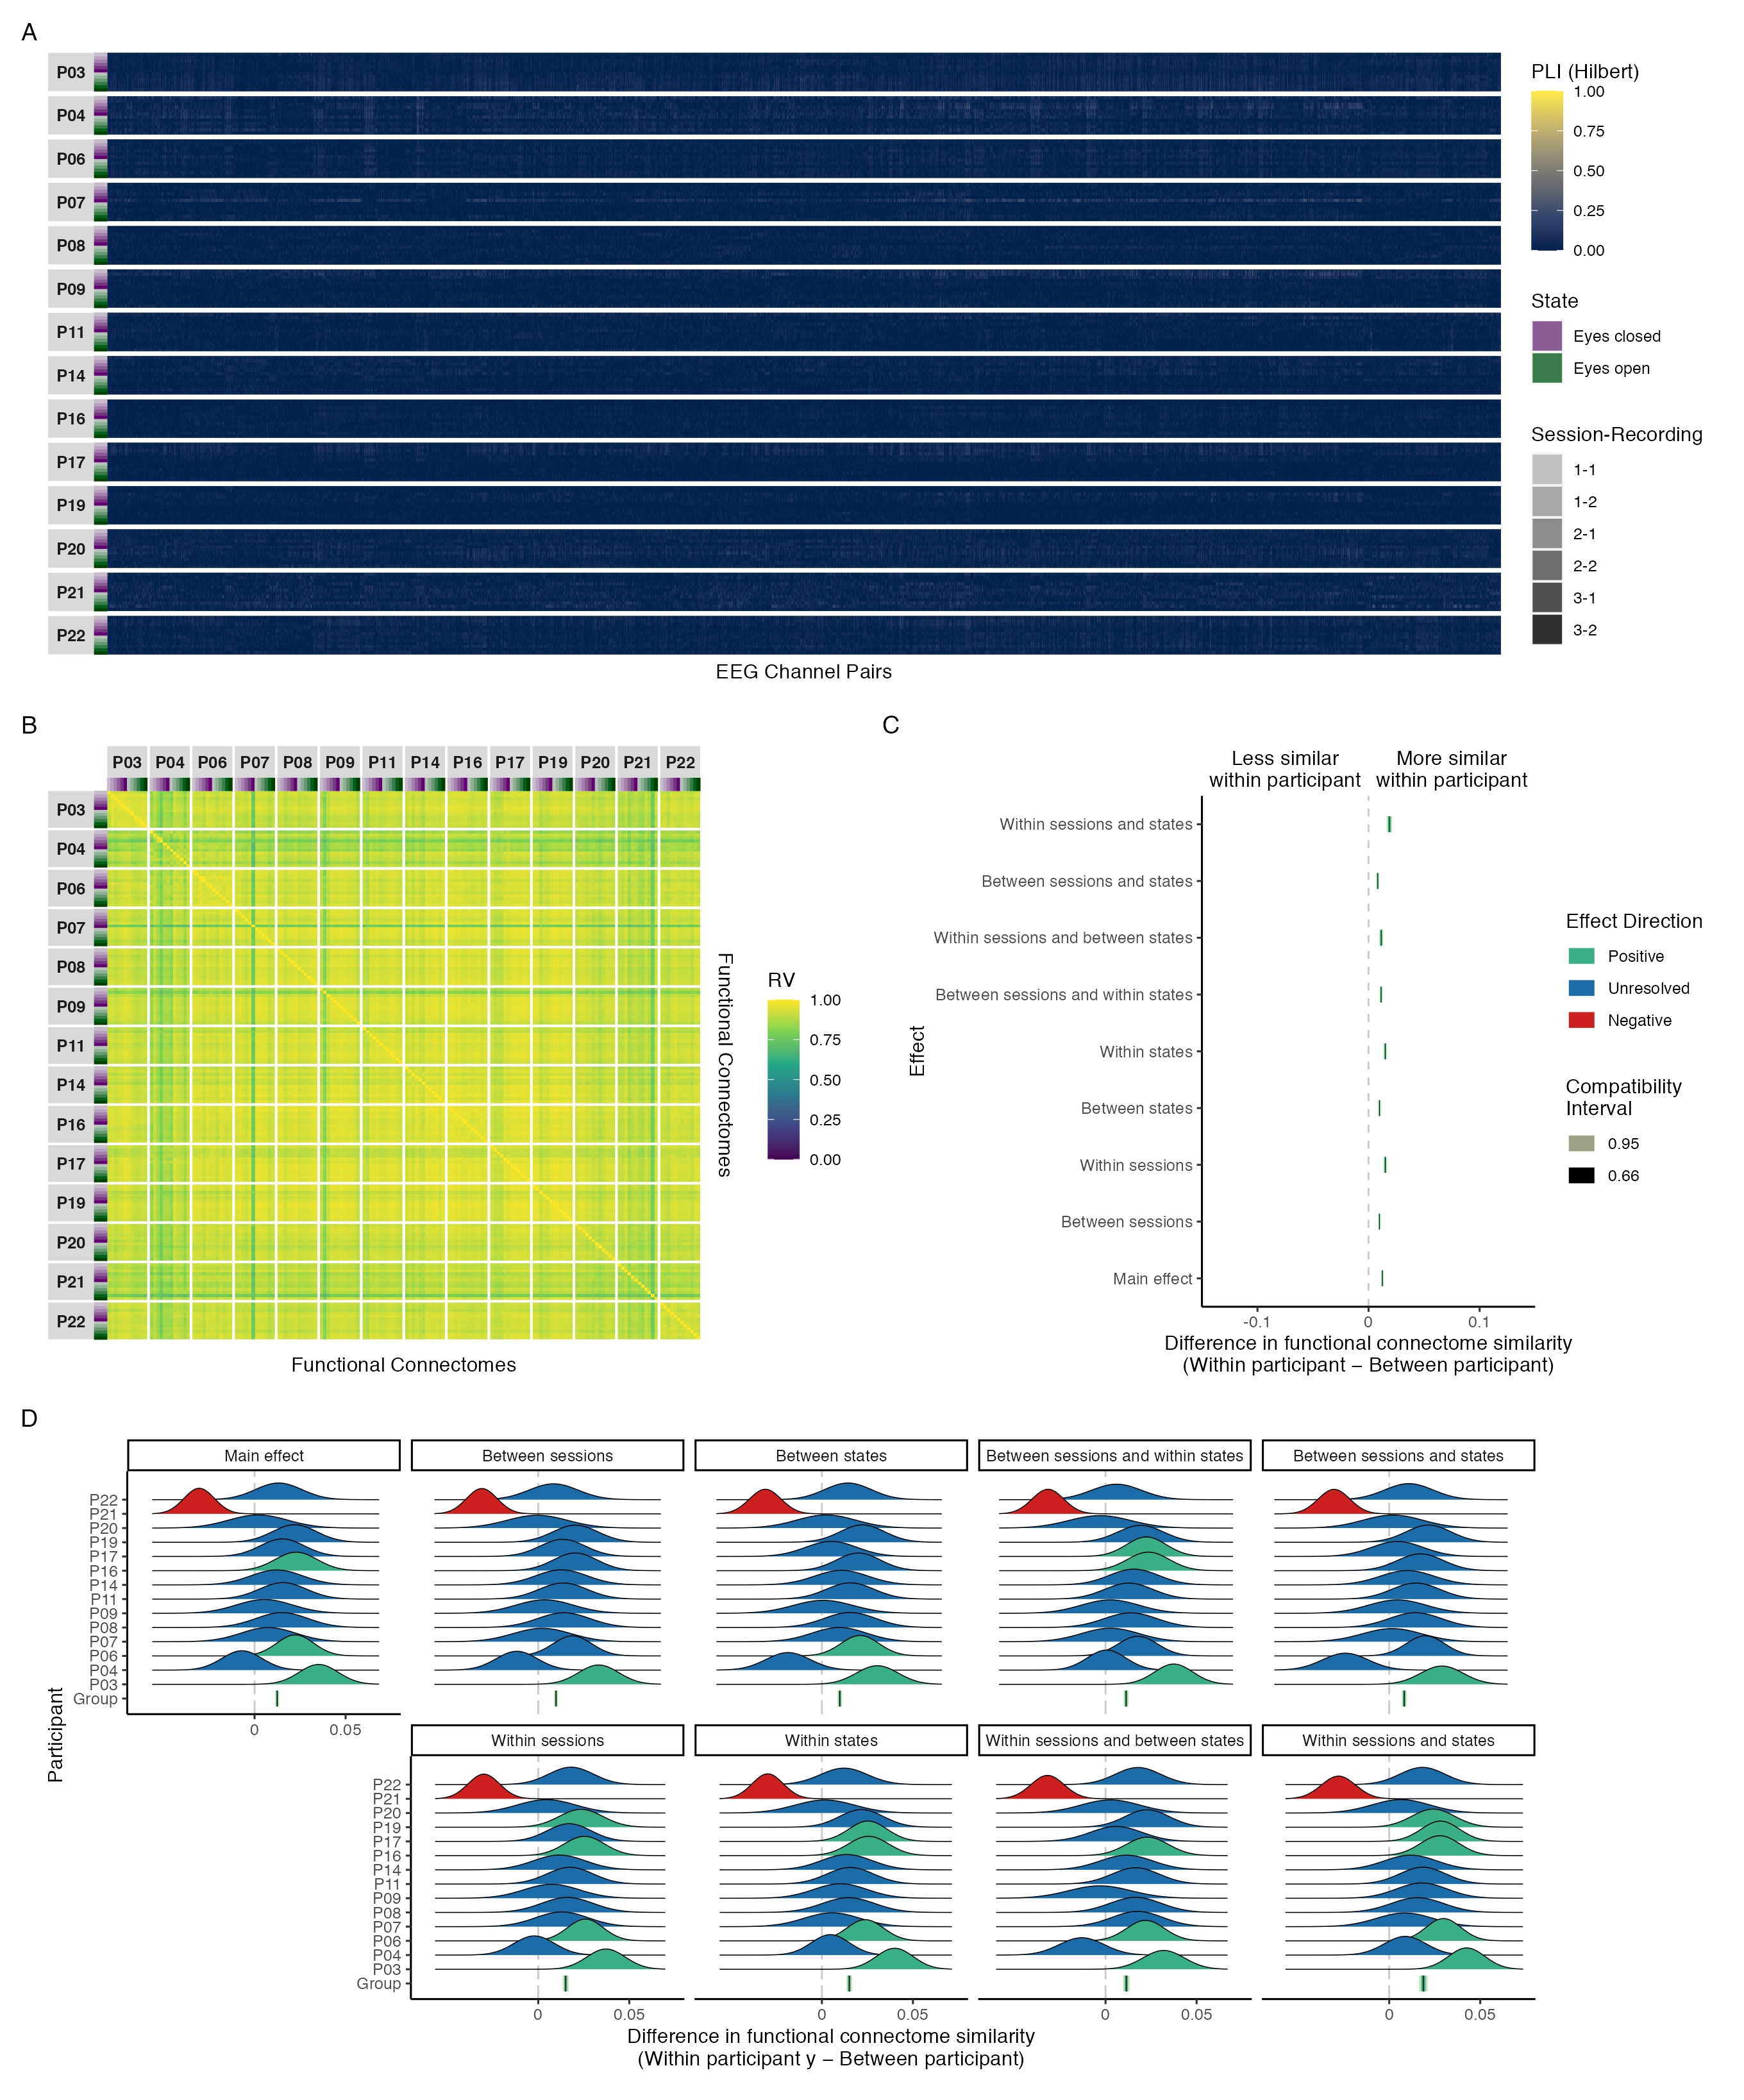

Figure 10: Connectivity profile matrix (A), similarity matrix (B), interval plot (C), and ridge plots (D) for phase coupling functional connectome similarities in the beta band.

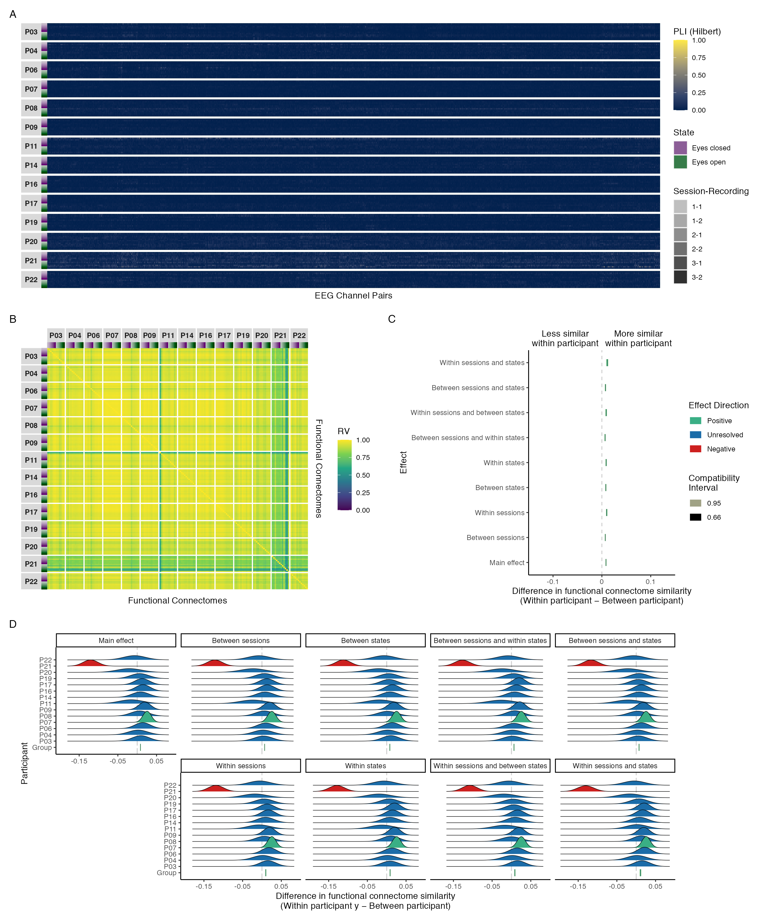

Figure 11: Connectivity profile matrix (A), similarity matrix (B), interval plot (C), and ridge plots (D) for phase coupling functional connectome similarities in the gamma band.